Reading Guidance for Parents 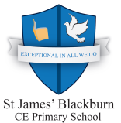

Research has shown that children who enjoy reading for pleasure have better reading and writing skills, a wider vocabulary and even an increased general knowledge and understanding of other cultures. Reading is without doubt, one of the most important skills your child will ever learn.
It is vital that not only does your child read regularly at home with an adult but that they also discuss their reading books with an adult.
Reading can help your child in all subject areas - from word problems in Mathematics, researching new topics in Science to exploring different facts for History lessons. Reading will also help your child develop new vocabulary and ideas to use in their writing and improve their spelling!
But with so many other activities competing for children’s time how can you continue to encourage your child to read for pleasure?
Here are some tips to support your child in reading:
- Model reading at home. Let them see you read at home, it doesn’t matter if it’s a newspaper, cookery book, manual, magazine, anything!
- To show your child that you have a keen interest in their reading, listen to your child read, share the reading and talk about it
- Encourage children to join in with reading at home, read out a recipe as you cook or the TV listings.
- Give and encourage others to give books or book tokens as presents.
- Visit your local library together on a regular basis, enjoy choosing books together.
- Don’t panic if your child reads the same book over and over again.
- Encourage your children and friends to swap books – that will get them an opportunity to talk about their reading.
- Let your child subscribe to their favourite magazine.
- To develop comprehension skills, ask questions about the text. Why did you choose this book? Summarise what’s happened so far. What might happen next? What sort of character is ...? How would you feel if ...?
Reading at home with your child
Remember reading at home is NOT a test! It should be an enjoyable experience for both yourself and your child. Tell your child any unfamiliar and tricky words before they start reading. Explain new words to them and discuss the pictures, which are also called illustrations.
Devote a particular time as frequently as possible to reading. It might be straight after breakfast or just before bedtime. For your child to make good progress at school with their reading, please ensure they read at least three times a week at home. This could include their school books, reading games on reading eggs, newspapers, comics and other reading material such as recipe books.
Ensure your child reads a range of fiction and non- fiction (information) books. Also allow your child to make their own reading choices and express their own preferences.
Strategies for Early Readers EYFS and KS1
If your child is an early reader, taking turns with your child whilst reading can make reading more enjoyable. This way you can read parts of the book to your child and demonstrate expression, good fluency and accuracy.
Remember to use phonics to help your child break up unknown or longer words. Please see the document ‘Phonics Guidance for Parents’ to support you in this.
When a word cannot be broken up into sounds then ask your child if they can see any clues in the pictures to help them with that word. You can also ask your child which word would make sense in that sentence. These are three key strategies to reading :
Visual- Using letters and phonics
Meaning- Using the illustrations and context of the story/book
Syntax- Using grammar and sentence structure to help solve a word
Other reading strategies include - reading to the end of a sentence and then coming back to the difficult word, using a story voice filled with expression and giving time to your child to solve words independently or self-correct their own errors.
KS2 or Developing Readers
As your child gets older and enters Year Two and then Key Stage Two, as well as reading with accuracy, fluency and expression (see above strategies for younger children ), they will also be expected to infer what the book or story is telling them. This means thinking deeper about the meaning behind the text. The answer lies in their interpretation of the text.
Discussing characters feelings, motives and actions can help your child understand what they are reading at a deeper level. Also exploring new vocabulary and phrases which the author has used can also help your child to answer more complex comprehension questions.

Discussing a Book and Asking Questions
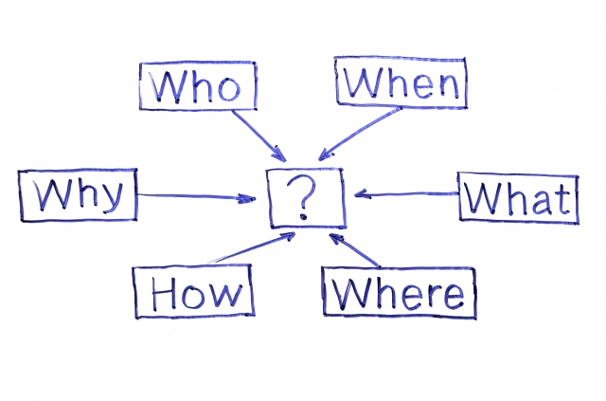
Ask your child plenty of questions before, during and after their reading. Some example of questions you could ask are given below:
What do you think this story/book will be about?
Can you tell me what is happening in the first few pictures?
What does the blurb ( summary on the back cover) and title tell us?
What has happened so far?
Why do you think the character feels that way?
What do you think the character might say or do next?
How is the setting described?
Find me a word on page ….that means the same as……
What information have we found out?
What do you like best about this book and why?
Find three exciting words the author has used.

Signing and Recording Comments in your Child’s Homework Planner
Please sign your child’s reading record (in their homework planner) every time that they have read with an adult at home and discussed their book. Older KS2 children may choose to write their own comments about a book in their homework planner. As a parent you can also add your own comments into your child’s planner. This may include comments on their expression, any words which they found difficult and any strategies which they used well. Remember to use lots of praise! This will encourage your child on their reading journey and motivate them to read.
Some examples of comments include:
‘Mohammed read well today with lots of expression and a story voice.’
‘Alisha tried hard to solve new words using her phonics and sounds.’
‘Daniel looked at the pictures to help him solve new words. ‘
‘Aminah understood the story and asked lots of questions about the book. ‘
Thank you for taking the time to read this guidance. We really hope it helps you to support your child’s reading.
If you have any questions about reading or are concerned about your child’s reading progress please speak to your child’s class teacher, Mrs Madbouli (Core Curriculum Leader and Assistant Head Teacher) or Miss Limbada (specialist Reading Recovery teacher and Reading Subject Leader).

